# Supplemental Materials

## EGRET output for each site

## Trends

Table S1: Net Change in annual FN SRP Concentration between 2008-2022 and 2015-2022. Statistical likelihood was based on the EGRETci package using a nboot of 100.

|  |  |  |  |  |  |  |  |  |  |  |
| --- | --- | --- | --- | --- | --- | --- | --- | --- | --- | --- |
| Site | FN SRP concentration | | | | | | | | | |
| Change, 2008-2022 | | | | | Change, 2015-2022 | | | | |
| Annual mean concentration in 2008, mg/L | mg/L | % | Trend Direction | Statistical Likelihood | Annual mean concentration in 2015, mg/L | mg/L | % | Trend Direction | Statistical Likelihood |
| BLA | 0.10 | 0.13 | 128 | Up | Highly likely | 0.20 | 0.04 | 12 | Up | Very likely |
| HON | 0.08 | -0.01 | -10 | Down | Likely | 0.08 | -0.005 | -6 | Down | Likely |
| MAU | 0.07 | 0.003 | 0.5 | Up | As likely as not | 0.07 | -0.004 | -6 | Down | Likely |
| POR* | 0.06 | 0.06 | 100 | Up | Highly likely | 0.08 | 0.04 | 53 | Up | Highly likely |
| RAI | 0.02 | 0.01 | 69 | Up | Highly likely | 0.03 | 0.004 | 11 | Up | Likely |
| SAN | 0.05 | 0.02 | 33 | Up | Highly likely | 0.06 | 0.01 | 23 | Up | Highly likely |
| TIF | 0.05 | -0.004 | -7 | Down | Likely | 0.06 | -0.01 | -17 | Down | Highly likely |

Table S2: Net Change in annual FN SRP Flux between 2008-2022 and 2015-2022. Statistical likelihood was based on the EGRETci package using a nboot of 100.

|  |  |  |  |  |  |  |  |  |  |  |  |  |
| --- | --- | --- | --- | --- | --- | --- | --- | --- | --- | --- | --- | --- |
| Site | FN SRP Flux | | | | | | | | | | | |
|  |  | Change, 2008-2022 | | | |  |  | Change, 2015-2022 | | | |
| Total annual flux in 2008, metric ton/yr | Total annual yield in 2008, kg/km2/yr | Metric ton/yr | % | Trend direction | Statistical likelihood | Total annual flux in 2015, metric ton/yr | Total annual yield in 2015, kg/km2/yr | Metric ton/yr | % | Trend direction | Statistical likelihood |
| BLA | 37.8 | 42 | 13 | 33 | Up | Highly likely | 45 | 50 | 6 | 12 | Up | Highly likely |
| HON | 21.2 | 55 | 0 | 1 | Up | As likely as not | 22 | 58 | -1 | -4 | Down | Likely |
| MAU | 601 | 37 | -35 | -6 | Down | Likely | 604 | 37 | -38 | -6 | Down | Likely |
| POR* | 43.5 | 39 | 5 | 12 | Up | Very likely | 45 | 41 | 4 | 9 | Up | Highly likely |
| RAI | 28.3 | 10 | 6 | 21 | Up | Very Likely | 38 | 14 | -4 | -10 | Down | Very likely |
| SAN | 122 | 38 | 27 | 22 | Up | Highly likely | 134 | 41 | 15 | 11 | Up | Highly likely |
| TIF | 25 | 24 | -2 | -7 | Down | As likely as not | 28 | 26 | -5 | -17 | Down | Highly likely |

Table S3: Net Change in annual FN TP Concentration between 2008-2022 and 2015-2022. Statistical likelihood was based on the EGRETci package using a nboot of 100.

|  |  |  |  |  |  |  |  |  |  |  |
| --- | --- | --- | --- | --- | --- | --- | --- | --- | --- | --- |
| Site | FN TP concentration | | | | | | | | | |
| Change, 2008-2022 | | | | | Change, 2015-2022 | | | | |
| Annual mean concentration in 2008, mg/L | mg/L | % | Trend Direction | Statistical Likelihood | Annual mean concentration in 2015, mg/L | mg/L | % | Trend Direction | Statistical Likelihood |
| BLA | 0.24 | 0.15 | 63 | Up | Highly likely | 0.32 | 0.06 | 19 | Up | Highly likely |
| HON | 0.19 | 0.03 | 14 | Up | Highly likely | 0.202 | 0.02 | 10 | Up | Highly likely |
| MAU | 0.23 | 0.01 | 6 | Up | Likely | 0.228 | 0.02 | 9 | Up | Highly likely |
| POR* | 0.15 | 0.07 | 48 | Up | Highly likely | 0.176 | 0.05 | 28 | Up | Highly likely |
| RAI | 0.082 | 0.03 | 39 | Up | Highly likely | 0.1044 | 0.01 | 10 | Up | Very likely |
| SAN | 0.20 | 0.05 | 24 | Up | Highly likely | 0.195 | 0.055 | 28 | Up | Highly likely |
| TIF | 0.16 | 0.01 | 6 | Up | Likely | 0.176 | -0.008 | -5 | Down | Likely |

Table S4: Net Change in annual FN TP Fluxes between 2008-2022 and 2015-2022. Statistical likelihood was based on the EGRETci package using a nboot of 100.

|  |  |  |  |  |  |  |  |  |  |  |  |  |
| --- | --- | --- | --- | --- | --- | --- | --- | --- | --- | --- | --- | --- |
| Site | FN TP Flux | | | | | | | | | | | |
|  |  | Change, 2008-2022 | | | |  |  | Change, 2015-2022 | | | |
| Total annual flux in 2008, metric ton/yr | Total annual yield in 2008, kg/km2/yr | Metric ton/yr | % | Trend direction | Statistical likelihood | Total annual flux in 2015, metric ton/yr | Total annual yield in 2015, kg/km2/yr | Metric ton/yr | % | Trend direction | Statistical likelihood |
| BLA | 137 | 153 | 27 | 20 | Up | Highly likely | 141 | 157 | 23 | 16 | Up | Highly likely |
| HON | 68 | 176 | 13 | 19 | Up | Highly likely | 74 | 191 | 7 | 9 | Up | Highly likely |
| MAU | 2410 | 147 | 254 | 10 | Up | Very likely | 2360 | 144 | 308 | 13 | Up | Highly likely |
| POR* | 155 | 140 | 35 | 22 | Up | Highly likely | 164 | 148 | 26 | 16 | Up | Highly likely |
| RAI | 109 | 40 | 55 | 50 | Up | Highly likely | 143 | 53 | 21 | 14 | Up | Very likely |
| SAN | 529 | 163 | 168 | 32 | Up | Highly likely | 549 | 169 | 149 | 27 | Up | Highly likely |
| TIF | 81 | 76 | 17 | 20 | Up | Highly likely | 94 | 88 | 4 | 4 | Up | Likely |

## Seasonal drivers

Table 4: Differences between seasonal and annual rates of change from 2008 to 2022 in FN SRP concentration and flux, in percent per year.

|  |  |  |  |  |  |  |  |  |
| --- | --- | --- | --- | --- | --- | --- | --- | --- |
|  | FN Concentration | | | | FN Flux | | | |
|  | Fall | Winter | Spring | Summer | Fall | Winter | Spring | Summer |
| BLA | 4.8 | 1.2 | -2.9 | 0.4 | 0.6 | -0.4 | 0.0 | 1.6 |
| HON | 0.0 | -0.4 | 0.3 | -0.2 | -0.2 | -0.3 | 0.3 | 0.3 |
| MAU | 2.8 | -1.0 | -0.3 | 2.5 | 1.9 | -0.1 | -0.3 | 2.4 |
| POR* | 1.0 | -7.1 | -1.5 | 11 | 0.1 | -1.4 | 0.5 | 4.9 |
| RAI | 0.3 | -5.2 | -0.5 | 10 | 1.1 | -1.2 | 0.0 | 8.3 |
| SAN | 0.8 | -2.0 | -0.1 | 4.3 | 0.8 | -0.5 | 0.1 | 2.7 |
| TIF | 0.1 | -1.2 | 0.0 | 1.0 | 0.8 | -0.1 | -0.2 | 0.7 |
| Average | 1.4 | -2.2 | -0.7 | 4.1 | 0.7 | -0.6 | 0.1 | 3.0 |

Figure 1:

Table 5: Differences between seasonal and annual rates of change from 2008 to 2022 in FN TP concentration and flux, in percent per year.

|  |  |  |  |  |  |  |  |  |
| --- | --- | --- | --- | --- | --- | --- | --- | --- |
|  | FN Concentration | | | | FN Flux | | | |
|  | Fall | Winter | Spring | Summer | Fall | Winter | Spring | Summer |
| BLA | 3.4 | 0.8 | -1.9 | 1.1 | 1.3 | 0.1 | -0.3 | 1.3 |
| HON | 0.3 | -0.3 | 0.0 | 0.2 | 0.6 | -0.5 | 0.2 | 0.8 |
| MAU | 0.4 | -0.2 | 0.0 | 0.2 | 0.7 | 0.0 | -0.1 | 0.0 |
| POR* | 1.9 | -1.6 | -1.1 | 4.0 | 1.3 | -0.4 | -0.2 | 2.5 |
| RAI | -0.7 | -1.2 | 0.7 | 0.5 | -0.8 | -0.6 | 0.5 | -0.4 |
| SAN | 0.7 | 0.2 | -0.2 | -0.2 | 2.1 | 0.2 | -0.4 | 1.3 |
| TIF | -0.5 | -0.3 | 0.5 | -0.5 | -0.3 | -0.2 | 0.2 | -1.3 |
| Average | 0.8 | -0.4 | -0.3 | 0.8 | 0.7 | -0.2 | 0.0 | 0.6 |

Figure 2:

### SRP concentrations

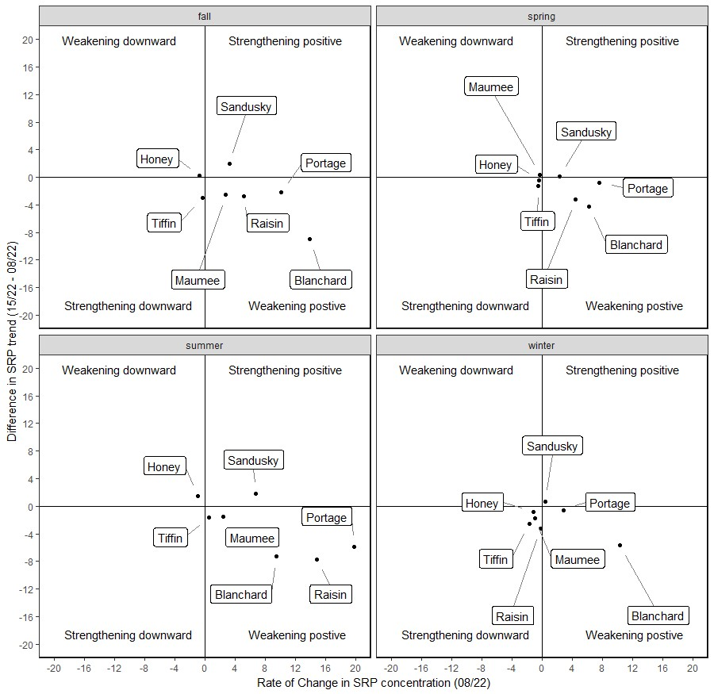

## Extreme events

Along with trends in mean concentrations and fluxes, we were also interested in the number of extreme P loss events. Using the “actual” daily concentrations from the WTRDS-Kalman filter, the number of days in which the daily SRP and TP exceeded 0.1 mg/L and 0.75 mg/L, respectively, were counted for each year at each site. To determine whether the frequency of predicted SC exceedance has changed over time, trends in the number of extreme events were assessed using the Mann-Kendall test with Theil-Sen slope estimates over the period of record for both seasonal and annual data.